**National Business Honor Society of Livingston High Schoo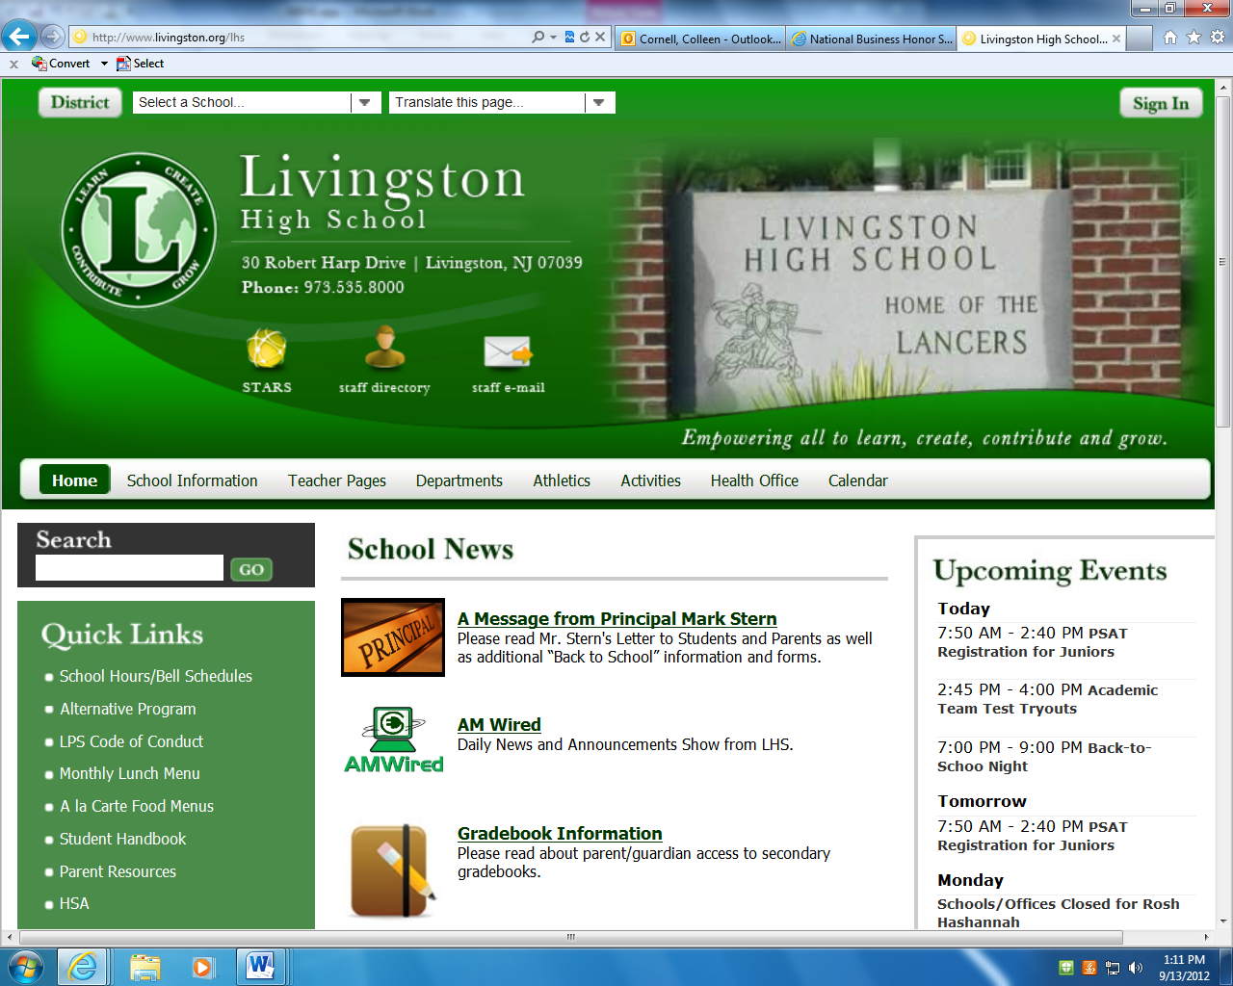l**

***APPLICATION***

\*\*\****MUST* be returned no later than** **Friday, September 16, 2016** to Advisors: Mrs. Pronko or Mrs. Cornell***

Last Name First Name Junior or Senior

List all **CURRENTLY ENROLLED (2016-2017 courses) AND** **COMPLETED (2015-2016 and prior)** business courses:

|  |  |
| --- | --- |
| **COURSE** | **COURSE** |
|  |  |
|  |  |
|  |  |

**COMPLETE items 1-3 below and attach your responses to this application.***.* ***All 3 requirements listed below must be submitted with your application, unless you are a returning member, then only submit items 2 & 3 with your application.***

1. **ESSAY REQUIREMENT**: Choose the **one** core virtue that best describes your character and explain. (Caring, Integrity, Citizenship, Leadership, Cooperation, Loyalty, Courage, Perseverance, Fairness, Respect/Self-Control, Honesty, or Responsibility) (No more than 150 words, typed, double-spaced)
2. **Complete the Leadership/Service Activities/Employment History** section of this application with a list of your service activities and/or employment experiences. Please make sure this form provides the contact information to verify your participation in these activities.
3. **Attach your LHS unofficial transcript. You must obtain this from Guidance.**

**Printed Student Name:** _______________________________ **Printed Parent/Guardian Name**: ____________________________

**Student Signature**:___________________________________ **Parent/Guardian Signature**:________________________________

--------------------------------------------------------------------------------------------------------------------------------------------------------------------------------

**For Office Use**: Received by: __________________________ Date: __________________

Meets Criteria: Does Not Meet Criteria: Initials:_________________ Date: ______________

|  |  |  |  |
| --- | --- | --- | --- |
| **ACTIVITY/JOB NAME** | **DATES** | **BRIEF DESCRIPTION** | **CONTACT PERSON & EMAIL or  PHONE NUMBER** |
|  |  |  |  |
|  |  |  |  |
|  |  |  |  |
|  |  |  |  |
|  |  |  |  |
|  |  |  |  |
|  |  |  |  |
|  |  |  |  |

**Leadership/Service Activities/Employment History**